**Order-Any-From-Any**

A PROJECT REPORT

*Submitted by*

**Prashant Sharma 20BCS9390**

**Kunal Kashyap 20BCS1815**

**Pratigya Ballouria 20BCS1834**

**Mantasha Khan 20BCS3175**

***In partial fulfilment for the award of the degree***

**Bachelor of Engineering**

**In**

**Computer Science and Engineering**



**Submitted to:**

**Supervisor: Evaluation Panelists**

**Mupnesh Kumari (E15012) Arvind Goutam (E13182) Chitra Sharma (E13181)**



**BONAFIDE CERTIFICATE**

Certified that this project “**CU-FOS**” is the bonafide work of our group

which includes  **“Prashant Sharma”, Kunal,Pratigya,Mantasha**, who carried out

the project work under my/out supervision.

**Signature SIGNATURE**

**HEAD OF THE DEPARTMENT SUPERVISOR**

Submitted for the project viva-voice examination held on ___________

**INTERNAL EXAMINER EXTERNAL EXAMINER**

ACKNOWLEDGEMENT

We express our sincere regards and gratefulness to our Supervisor ‘ **Mupnesh Kumari (E15012)** (‘**Dept. of Computer Science and Engineering, Chandigarh University’)** for giving us his Valuable time, guidance ,support and his encouragement throughout this project. We would also sincerely like to thanks our **Evaluation Panellist’s Arvind Goutam (E13182) and Chitra Sharma (E13181)**for giving us this opportunity to work under his Guidance and Share our Experience which help us a lot to build our Technical Skills while undergoing this Project. This Project helps us to developed our skills in various Parameter in Android Development which are involved development in the front end or user Interface(UI) along with the back end to create a fully functional android application along with database.

We would like to thanks to our Computer Science Department for giving this opportunity that I came to know about so many thing. I am really thankful to them. I also like to thank my teammate to finalizing this project within the limited time frame.

ABSTRACT

CHANDIGARH UNIVERSITY FOOD ORDERING SYSTEM (Cu-FOS) targeted for the food management of the university for better control and timely response. By this application we close the gap between student and shops. We targeted many shops in the University to came all together under one platform named Cu-Fos. The Reason for making this application is to reduce the manually work for managing Orders, Items category and delivery. One more reason for making this application is to reduce the time and student crowd which stayed in queue for long time to taking the order and reduce stealing in money like many students has taken the order and due to crowd the shop owner didn’t recognize the order so many of the one does not pay for the order due to this the owner is getting loss.

The Aim of this project is to connect you the web world where we can easily fulfil our needs with the help of web. This website serves you an online platform where you can easily get your food without going anywhere just ordering it through the application and as much as fast you get into your destination.

**TABLE OF CONTENTS**

|  |  |  |
| --- | --- | --- |
| **Sr. No.** | **Topic** | **Page No.** |
| 1. | Introduction | 1 |
| 2. | Literature Survey | 5 |
| 3. | Design flow/ Process | 11 |
| 4. | System Requirement Phase | 23 |
| 5. | Conclusion and Future Work | 26 |

**CHAPTER:1 INTRODUCTION**

The online food order system sets up an internet food menu associated customers will simply place an order the means they like. And with the food menu, online customers will place orders simply. Shopkeepers keep customer data, and develop a food delivery service. Food management systems encourage us to enhance the food purchasing.

1. **Identification of client and need:**

Everyone loves food and the need of food in India increases day by day. By increasing the demand of food many restaurants and shops faces many problems they have less workers to full fill the need of peoples. The online food order system sets up an online food menu and customers can easily place an order the way they like. Also, online customers can easily track their orders. Managers maintain customer records, and develop a food delivery service. This program also provides a feedback system where the user can measure food. Also, the proposed system can recommend hotels, meals, based on user ratings, hotel staff will be informed of progress and quality. Payment can be made online or in cash or by payment plan. To get more secure orders different accounts are stored for each user by giving him an ID and password.

1. **Relevant Contemporary Issues:**

The problem with manual adjustment is that you have to do everything yourself. That includes waiting for the money to come in and having your customers get the invoices passed on their deadline. It's соmрletely different when you have а streamlined online рrосess where you саn get on with doing what you love whilst letting your system аutоmаtiсаlly send electronic invoices and сhаrge customers by credit.

Let’s face it, calling your customers and asking them to play it has never been fun. It consumes your time, diverts your attention from completing other important tasks, and is not a conversation that anyone really wants to have.

The food industry is transforming with online food ordering apps.The restaurant online ordering system help in notifying the right people at the right time. It is not just about flexibility; it’s about protecting the customer base by staying connected with them. There are some explosive growth examples when it comes to online food ordering websites and apps. The best food ordering apps around the globe are UberEATS, Food Panda, Postmates, Grub Hub, Seamless, which have made the food ordering and delivery marketplace encouraging with ideas.

**3. Problem Identification:**

Today, many restaurants use the restaurant order system to help customers. CUFOS restaurant order system, employees record the food purchased by the customer order. The paper will then pass into the kitchen and the cook will start cooking. This caused a few distractions. Employees may make some mistakes while writing down an order.

Sometimes, when staff write in a hurry it will make the manuscript difficult to understand. Employees may lose the order paper and customers may receive incorrect credit. One of the problems facing restaurants that use the traditional order system is customers do not know when to prepare food. Other customers may have it the next schedule after lunch or dinner. They need to be able to prepare for the time they can they can plan their program wisely. Especially if there are many customers, customers may imagine that their order has been forgotten if their food has not been available in a long time. It will be so it is best if there is a limited amount of time to prepare food for the customers.

**4.Task Identification:**

Suppose the customer is hungry and does not have enough time to stand in queue in the shop and get the food of his choice. To solve this problem, he simply goes through the online food ordering application names Cufos. He simply searches many shops nearby him and according to his preference he choose his shops. There are lots of items in the menu of the shop so he simply places the order without getting any trouble he can order the very quickly and in very less time he get his food without any trouble. Using this application user can easily place the order through their smart phones, laptops, tablets and pc’s. User easily add to cart their order and payment will be done online, order can be delivered and customer can come and pick their order by themselves.

The main task of this application is to reduce labour cost, reduce queues, reduce paper work and reduce walk away. The online ordering application is designed in such a way where all the restaurants, shops, cafes can register their business in this application by which they will get more and more sales and improve their business reputation. Customer will have advantageous approach to order and discover many different shops through this application and seller get advantage to increases their customers through this cufos platform.

**5.Oraganization of the Report:**

The topic which we covered in the next chapters is to identify which technologies is use while implementing the project and gathering the requirements of the project, analyse the project and applying the test cases to check the validity of the project, find the software and hardware requirement, design the UML diagrams, design modules, design the system and lastly implementing and testing the project simultaneously.

After this introductory chapter,

**Chapter 2** is based on “Literature Survey” which will include some key points such as bibliometric analysis, proposed solutions by different researchers, summary linking literature review with the project, Problem Definition, Goals, Objectives and much more.

**Chapter 3** summarizes the Concept Generation, Evaluation & Selection of Specifications/Features, Design Constraints– Regulations, Economic,

Environmental, Health, Ethical, Social & Political Issues considered in design, Analysis and Feature finalization subject to constraints, Design Flow and much more.

**Chapter 4** presents the tools that are used in making the application and their latest features and advantages and the language in which the code is written and why.

**Chapter 5**, “Conclusion and Future Work” compiles the deviation from expected results and way ahead. Questions like, what are the future outcomes and what we have in our mind for the application in the coming future? will be answered in this section

**CHAPTER:2 LITERATURE SURVEY**

1. **Introduction:**

The paper describes an online food menu organized by the proposed food order system and at will customers can easily place an order. Also, customers can easily track orders through the menu. Managers develop a food delivery service and maintain customer information. The motivation for program development comes from the restaurant management system. To get the right services the users of the system provide a variety of services. Restaurants and Mess location are considered by our customer service system. Mostly messy users are people who are transferred to new cities and this can be considered a distraction from our system. Another incentive can be considered an increase in the use of smart phones by customers, so that any users of the system have access to the entire system service. The system will be designed to prevent users from making fatal mistakes where users can change their profile and where users cannot track their food. In an automatic food ordering system is proposed which will keep track of user orders intelligently. Basically, see implemented a food ordering system for different types of restaurants where the user will order or customize food with one click only. With an Android application for Tablets PC, this program is made. The front area was developed using JAVA, Android, and backend MySQL the website was used. In there was an attempt to design and implement it digital restaurant in restaurants using android technology. This program was a basic data usage system that downloads all information from the central website. This application has improved the accuracy and efficiency of restaurants and human error. Previous barriers to automatic food order systems are overcome by this the system also requires simultaneous investment in gadgets.

**2. Bibliometric Analysis:**

This restaurant ordering system has been developed to solve problems that will occur while using traditional order system. One of the problems facing the restaurant is traditional use order than is do not know the time to prepare food. This is an upgraded restaurant The order system allows customers to know the preparation time of their order. Therefore, they can easily plan their next schedule after their meal. In addition, customers may want cancelling their food. If you are using a standard order system, order cancellations include a few

steps. However, in this restaurant order system, customers can press a cancel button to cancel their order. The chef will know from the program dashboard. Moreover, it is it is difficult to tell all customers the latest menu information when ordering customers. Employees may forget to inform customers. For this restaurant order system, employees can update the latest menu information. Employees do not need to inform

**3. Proposed Solutions by Different Researchers:**

To overcome the system limitations above, based on The Internet of Things is an Online Food Ordering System proposed. The use of mobile technology has changed dramatically as Android devices have gained popularity in automation

of normal work in a wireless environment. For mobile devices like smart phones and tablets android is Linux built-in operating system. As a general purpose of research improve Reliable, Easy and Accurate Food Arrangements The system is considered. As a goal, a program that will do certainly customer service satisfaction will be considered. To design a system that can accommodate a large amount order on time and automatically calculate the bill is one important objective. One of the most important goals is to check its effectiveness and acceptance in terms of security, user interaction, accuracy and reliability. One of the the ultimate goal is to improve communication between client and customers.

**4. Summary linking literature review with the project:**

The restaurant may have more than one POS terminal. All restaurant terminals are available connected to the file server. Settings and settings are done on the server, then send back to terminals. If the restaurant accepts a credit card for payment, the third party provider is involved in credit card processing. The data will be sent to a bank or foreign company when employees do credit card work.

The power of this system can reduce the time it takes to order. This can also improve the customer satisfaction. By using this program, the time to take the order is accelerated. And it can reduce the mistakes that employees will make. Allows employees to track sales of restaurant. Employees are allowed to make daily and monthly sales reports on this program. Employees can also view the history of all orders.

**5. Problem Definition:**

The Online Food Ordering System deals with placing orders of food from various restaurants . This system involves the following functionalities :

1.**Collecting data** : The data is collected from the customer through the application.

2. **Verification of data** : The data collected( food ordered) from the customer is cross verified with the specific restaurant for availability.

**3. Order confirmation** : The order is confirmed by sending a confirmation text to the customer.

**4.Live tracker** : The live tracker will help the customer track current order status .

**5. Customer analytics** : Based on orders placed in various regions, suggestions of similar restaurants will be given .

**6. Customer feedback:** The customers will be able to rate their experiences, recommend changes and improvements to the current system.

**7. Modes of payment** : Multiple modes of payment will be provided while ensuring safe and secure online transactions.  
  
In this system we receive orders of food from customers, confirm them with restaurant provide live tracking facilities and ensure safe money transactions . The system also provides the customer the facility of rating their experience and suggesting improvements . This system also provides a feedback system in which user can rate the food items. Also, the proposed system can recommend hotels, food, based on the ratings given by the user, the hotel staff will be informed for the improvements along with the quality. The payment can be made online or cash or pay-on-delivery system. For more secured ordering separate accounts are maintained for each user by providing them an ID and a password.

**6.Problem Goals and Objectives:**

Start-ups, takeaways, and small restaurants find it difficult to manage order processes while providing quality food to their customers. Limited resources and other shortcomings especially during peak hours make it difficult for waiters and kitchen staff to sometimes meet customer needs. As a result, food quality is affected by taste and appearance.

The online food delivery solution addresses this issue with the help of the latest blockchain technology. Blockchain technology is a separate platform where kitchen staff can review a variety of items and processes used in real-time preparation. The manager or restaurant manager can access this information to ensure the quality of the food.

**The following Objectives of this project/application are:**

* To design a user-friendly system that provides latest information to customers
* To develop a system that include the preparation time of food
* To improve the communication between the client and the server and minimize the time of ordering.
* To automatically compute the bill.
* Easy to understand by the user.
* Shows the information and description of the item category ,Delivery Address.
* It tracks all the information of Food, customer and Order.
* Manage the Information of food.
* Provides filter by which you can choose best Rating restaurant
* To reduce the time of Staying in the queue of restaurant
* To increase the Efficiency to Managing the item Category, Food.

**7. Research Methodology**

The research methodology has many dimensions and methods of research. The scope of research methodology is broader than the research methodology. This was greatly appreciated by the researcher in conducting this study. Methodology is the basic principles and laws that govern the process of a program, on the other hand it is a systematic process of group work. Therefore, from these definitions the methodology encompasses the methods used within the study. The waterfall model under the software life cycle cycle (SDLC) is a term used to produce an online food order system and the customer order system itself. It is used by system developers to produce either information systems or software. Divides development process into several stages or processes. After the completion of one phase, it logically will move on to another phase. Sometimes a return to the previous phase is necessary because of the failure that occurs in the current phase. System design techniques are a discipline within the software development industry that seeks to provide a framework for recording and recording, storage, modification and dissemination of information in order to enable the economic development of purpose-oriented computer programs.

**CHAPTER:3 DESIGN FLOW/ PROCESS**

1. **Concept Generation:**

Online food ordering includes the innovation technology that solves problems within the food industry. The core idea behind online food ordering system application is self-explanatory.

It’s an application that helps people, shops, restaurant and cafes to manage food ordering system.

Manging the data of food items, category isn’t an easy an easy task for restaurant and shops because there are lots of problem face by seller and restaurant owner to gather the data by physically which very tough it’s a time-consuming task, requires more workers and is inefficient. Using our application can help to reduce a business administrative overhead on food ordering and reduce the impact of their delivery on their local society.

1. **Process Model:**

**Iterative Model**

The iterative process begins with the simple use of a subset of software requirements and repeatedly develops flexible versions until the full system is deployed. At each turn, design changes are made and new operational skills are added. The basic idea in this way is to improve the system with repetitive (repetitive) cycles and in small portions over time (increasing).

Repetitive and Upgrade upgrades are your combination of both repetitive design or repetitive method and a growing construction model for improvement.

"During software development, more than one repetition of the software development cycle may continue simultaneously." This process can be described as an "evolutionary method" or "a growing construction method". “In this add-on model, every requirement is divided into different structures. During each repetition, the development module goes beyond requirements, design, implementation and testing stages. Each subsequent release of the module can add function to the previous release. The process continues until the complete system is ready as required.

The key to the successful use of the life cycle of software development firmly confirms the requirements, and verifies and evaluates each version of the software against those needs within each cycle of the model. As the software changes with successive cycles, tests should be repeated and extended to confirm each type of software.

The repetitive life cycle model involves repeating the four stages listed below as a sequence. These are:

a) Requirements Category: In the software development requirements category, system-related information is collected and analysed. The collected needs are then organized accordingly to improve the system.

b) Design Phase: In the Design Phase, the software solution is tailored to meet the design requirements. The system design may be new or an extension of the previous structure.

c) Implementation and testing: In practice and in the testing phase, the system is developed by coding and building user interactions with modules and then integrating and testing.

d) Review Phase: The review phase is where the software is evaluated and tested according to the current requirement. Then, some of the requirements are reviewed and discussed in order to recommend an update to the next review.

**Iterative Model Diagram**

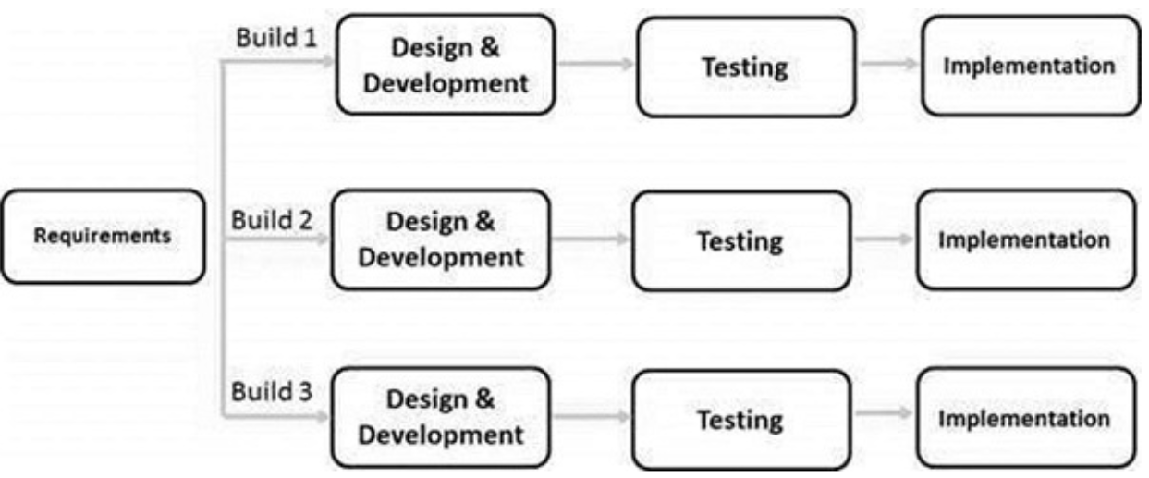

1. **Feasibility Study:**

This is an assessment and evaluation of the potential of the proposed project based on extensive research and research to support the decision-making process.

Assess the operational, technical and economic suitability of the proposed project. Possible research is intended for initial review of facts to determine whether it is appropriate to proceed to the analysis phase. From the perspective of a program analyst, evaluating whether it is possible is a key tool to recommend that you move on to the next phase or terminate a project.

* Technical feasibility:

This assessment focuses on gaining an understanding of the organization's current technology resources and their application to the expected requirements of the proposed system. It is hardware and software testing and how it meets the requirements of the proposed system. A systems project is considered technically feasible if the internal technical capacity is sufficient to support the project requirements. Key questions that help assess the system's technical performance include the following:

1. Is the project possible within the limits of current technology?
2. Does technology exist at all?
3. Is it available within the limits of the service provided?
4. Is the proposal effective?
5. Is it enough power-makers, testers and bug fixes?

* Operational feasibility:

Performance is a measure of how a project will support the customer and service provider during the performance phase. It depends on the human resources available to the project and includes specifying whether the system will be used when it is being developed and implemented. Key questions that help assess the technical feasibility of a system include the following:

1. Is the project possible or not?
2. Does the current operating system provide enough time to get out and respond?
3. Could there be a reduction in costs or an increase in profits?
4. Does the current system provide effective controls to prevent fraud and ensure the accuracy and security of data and information?
5. Do the current system make the most of the available resources, including people, time, and flow of forms?

* Economic feasibility:

This assessment aims to determine the positive economic benefits of the organization he proposed system will provide. It usually involves cost / benefit analysis and is the biggest one a frequently used method of evaluating the performance of a proposed new system. Questions that can be raised in economic analysis are:

1. Does the system cost apply?
2. Do the benefits outweigh the costs?
3. The cost of doing a full system study
4. Time spent on business activity
5. Estimated cost of software/software development
6. **Design Flow Diagram:**

Project design is an early phase of the project where a project's key features, structure, criteria for success, and major deliverables are all planned out

**Level 0:**

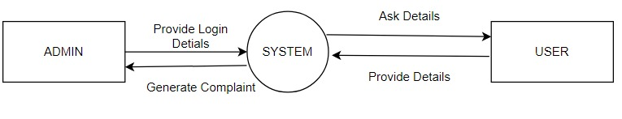

**Level 1:**

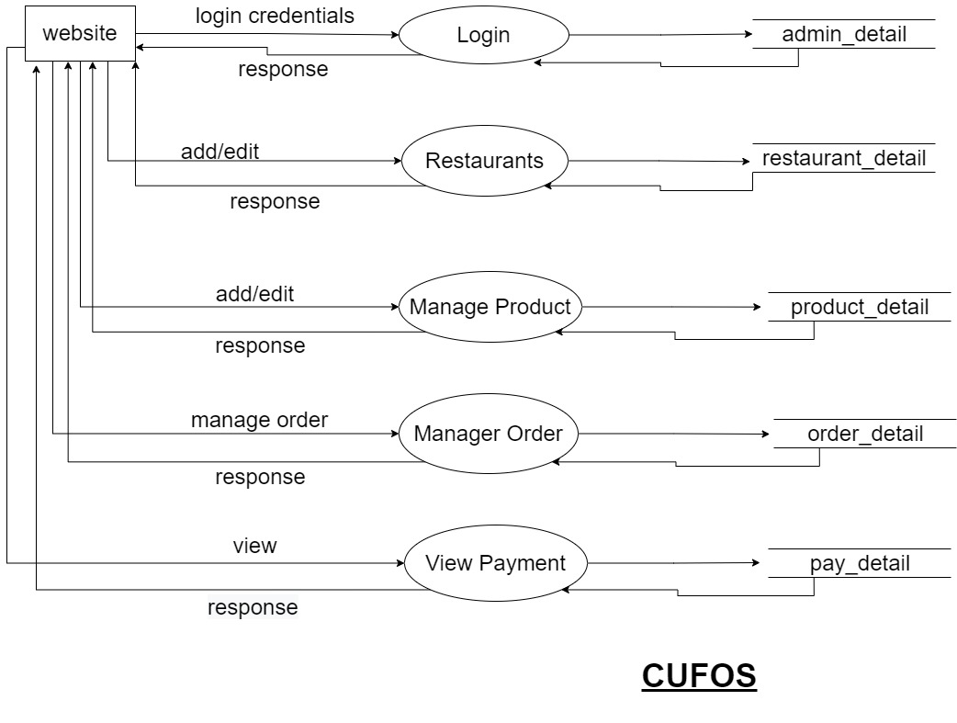

1. **Use-Case Diagram:**

The purpose of use case diagram is to capture the dynamic aspect of a system. However, this definition is too generic to describe the purpose, as other four diagrams (activity, sequence, collaboration, and State chart) also have the same purpose. We will look into some specific purpose, which will distinguish it from other four diagrams.

Use case diagrams are used to gather the requirements of a system including internal and external influences. These requirements are mostly design requirements. Hence, when a system is analysed to gather its functionalities, use cases are prepared and actors are identified.

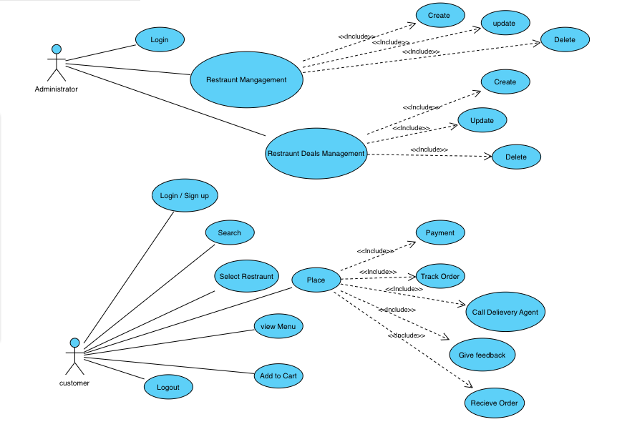

1. **ER Diagram:**

ER Diagram stands for Entity Relationship Diagram, also known as ERD is a diagram that displays the relationship of entity sets stored in a database. In other words, ER diagrams help to explain the logical structure of databases. ER diagrams are created based on three basic concepts: entities, attributes and relationships.

ER Diagrams contain different symbols that use rectangles to represent entities, ovals to define attributes and diamond shapes to represent relationships.

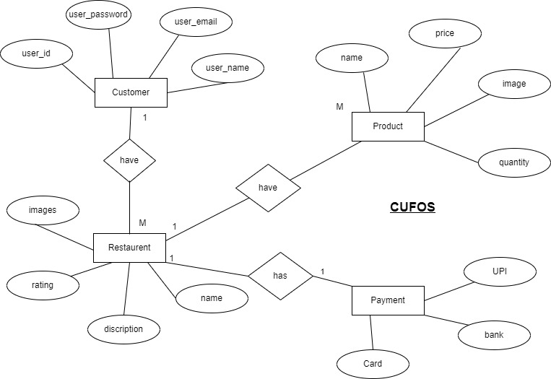

1. **Activity Diagram:**

The activity diagram is used to demonstrate the flow of control within the system rather than the implementation. It models the concurrent and sequential activities.

It helps in envisioning the workflow from one activity to another. It put emphasis on the condition of flow and the order in which it occurs. The flow can be sequential, branched, or concurrent, and to deal with such kinds of flows, the activity diagram has come up with a fork, join, etc. It is also termed as an object-oriented flowchart. It encompasses activities composed of a set of actions or operations that are applied to model the behavioural diagram.

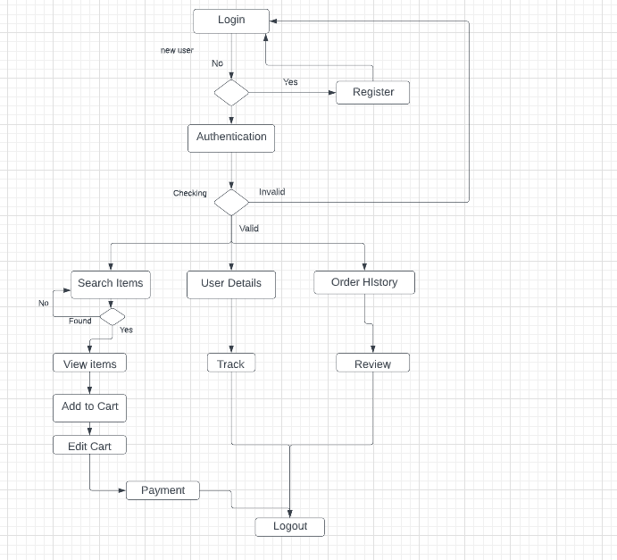

1. **Class Diagram:**

Class diagram is a static diagram. It represents the static view of an application. Class diagram is not only used for visualizing, describing, and documenting different aspects of a system but also for constructing executable code of the software application.

It describes the attributes and operations of a class and also the constraints imposed on the system. The class diagrams are widely used in the modelling of object-oriented systems because they are the only UML diagrams, which can be mapped directly with object-oriented languages.

It shows a collection of classes, interfaces, associations, collaborations, and constraints. It is also known as a structural diagram.

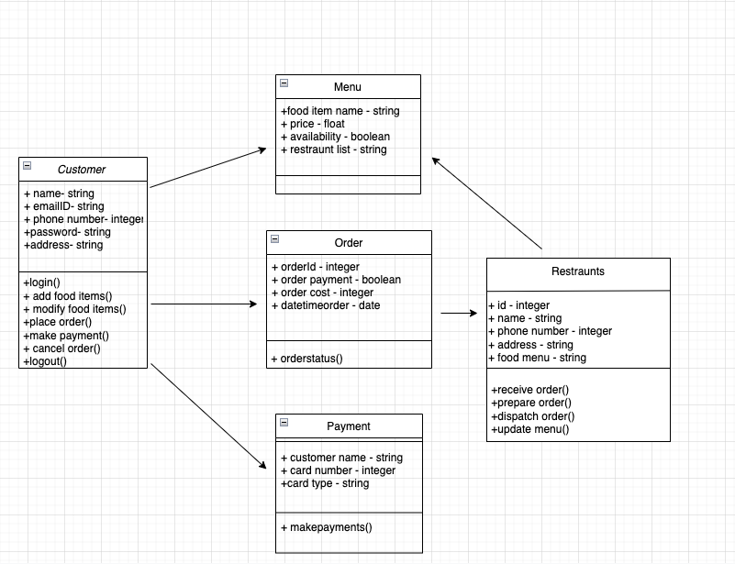

1. **Gantt Chart:**

A Gantt chart in Excel represents the breakdown structure of any project by displaying project start dates and end dates, along with intermediate relationships between relevant activities. This chart mainly shows projects or related tasks through cascading horizontal bars, which helps us monitor the project's overall performance for a defined timeline or planned milestone.

Gantt charts are considered an essential tool for the graphical representation of tasks or activities against pre-determined standards. It helps the users to regularly track the progress of tasks, projects or any relevant activity. Gantt chart is one of the essential tools in the field of project management. Unfortunately, the Gantt chart is not a part of the Excel inbuilt chart. Instead, it is created using a 2-D stacked bar chart that includes durations for tasks and specific formatting.

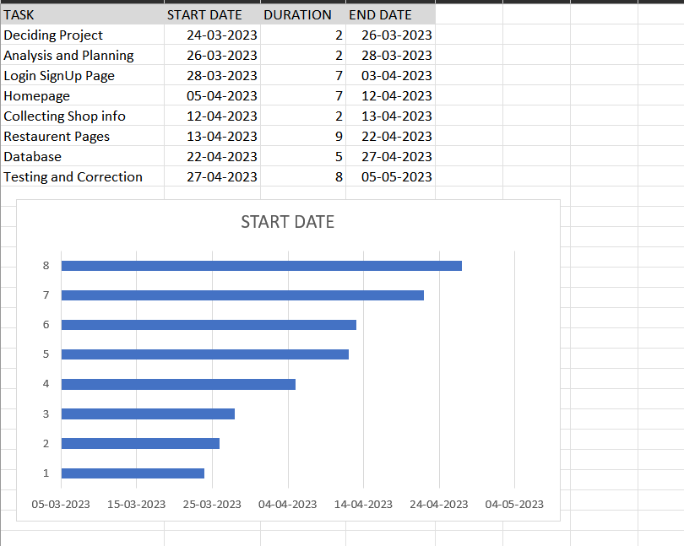

**CHAPTER: 4 SYSTEM REQUIREMENT PHASE**

1. **Title:**

**CUFOS**

1. **Technology:**

* **Front End:**

Front end refers to what you see in the interface of the application including the design. Front end also refers to the user experience and interacts with these things.

Developed with the help of android studio: 2021.2.1 (Chipmunk) Current version

Android Studio is the official integrated development environment for Google's Android operating system, built on JetBrains' IntelliJ

IDEA software and designed specifically for Android development.

* **Back End:**

Backend refers the work done by the admin front the backend of an process which includes the details and information which the database record in real-time difference for different users.

Backend section is done with the help of Firebase database and it's authentication and real-time database features.

This database is a cloud hosted NoSQL database that lets you store and sync the respective data between users.

1. **Modules:**
2. **Data records:**

**User Records:**

This record helps the organization to record the data of each and every single identity who uses the application and records their unique username and password for further usability of application and this track record make many other things easy too.

1. **Report:**

**Support Us:**

User can easily contact us via support us section. In this section we gave 2 entities

* Call us.
* Gmail us

1. **Hardware and software requirements:**

* Processor Type: 1.6 GHz Intel Core i5.
* System Ram: 8g b or above.
* Input Device: Keyboard and touchpad.
* Output Device: Standard color monitor.
* Operating System: Mac OS.
* Front end: Android studio -2021.2.1 (Chipmunk).
* Backend: Firebase.

**CHAPTER:5 CONCLUSION/ FUTURE WORK**

A food order system is made online that allows customers to order food and avoid the hassle of waiting for a waiter to take their order. Using the application, end users order food online by registering online, reading a

Menu card, and food options from a Menu card. After the customer has selected the required product , the chef can view the result in screen and start processing food. This the application eliminates the need for a waiter or reduces the workload a Wet. The advantage is that in a busy area the restaurant has a chance that the waiter will be very crowded orders and can meet the needs satisfactorily

customers. So users can use this app to order food directly Chef online. I conclude, The online food order system is useful for areas such as small family restaurants and university restaurants were proposed. In the future, the project could be expanded scale. The restaurant is designed to simplify the day-to-day management and operations, while improves customer self-awareness. We also help for , restaurant owners form healthy relationships with , customers by providing quality service. the system allows restaurants to see things in real time, complete commandments, and reconciliation list of foods and beverages.

By ordering online on board you will enrich your customer information by making the 'ordering process' process much easier. It will show that you value your customer time. Ordering online will ensure a 'high quality' in your web presence. And having a good web presence will make you stand out in search engine rankings and bring more customers to you.

Ordering online will improve your productivity by eliminating inefficient order-taking process. It will help you plan and implement a flexible marketing campaign.

Utilizing the latest online ordering technology of your restaurant will also help you get into a great customer support that is technically knowledgeable and believes in the ‘internet path’.

**USER MANUAL**

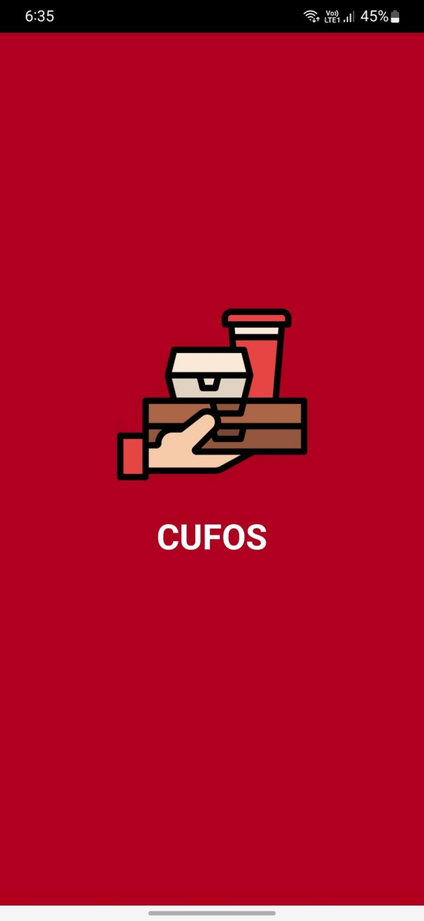

After successful installation of the application if you click on the icon this animated loading screen will appear.

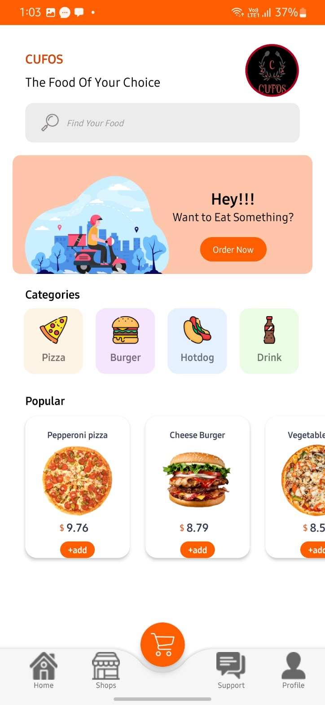

This will be first screen a user will see and we have designed it very user friendly and all the features are bundled in this screen only than further activities are linked .

User can simply click on the respective needed option.

By clicking on the Shops user will redirect to menu of that shops where user find the images of item, price and description about that product

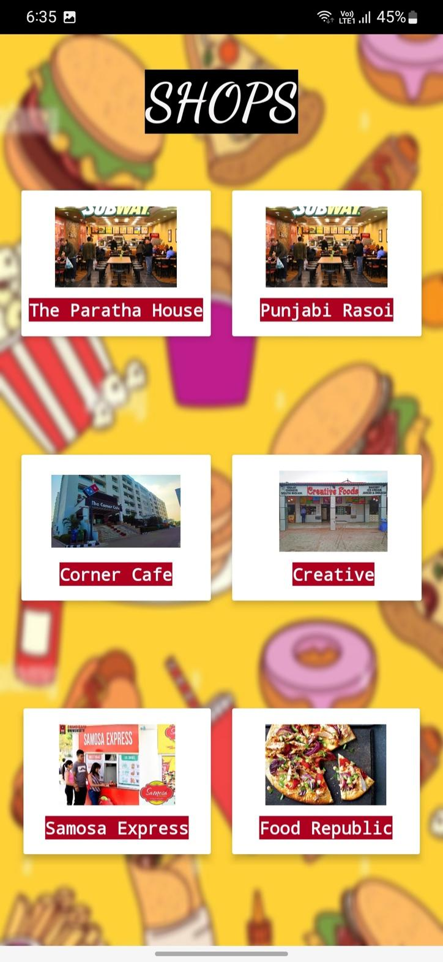

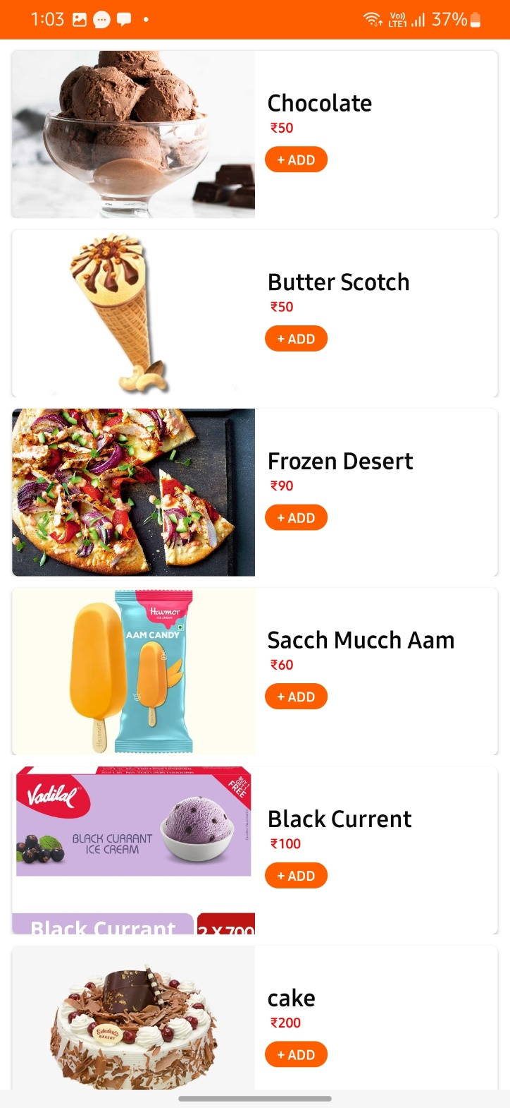

By clicking on the Support option user can contact us very easily with the help of a customer services.

Similarly, there are many services bundled inside the application user can enjoy them too by just some simple clicks.

If someone need any type of instant assistance, they can tap on the helpline feature. This feature will redirect them to next activity where can get instant assistance by some simple taps. Portal for the same is shown below in the image.

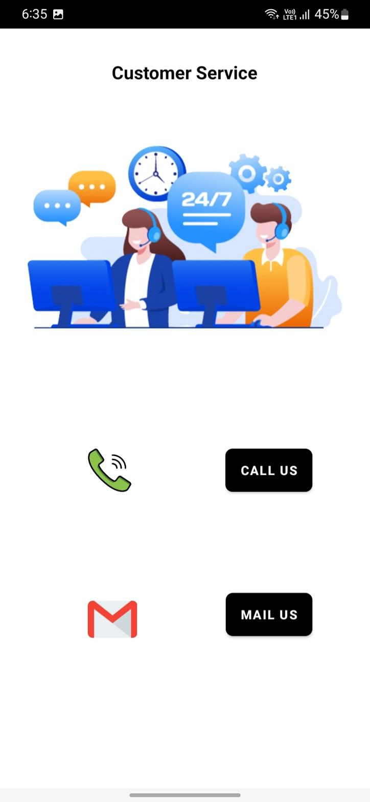

By tapping the call us icon, user will be redirected to the 24/7 Helpline number and the query will be entertained there.

And, for suggestions and further queries user can tap on the mail us option.

Here is Signin and Signup page through which customer can registered through this application and these both pages are connected to authentication database.after successful signup user can login with the same email and password.

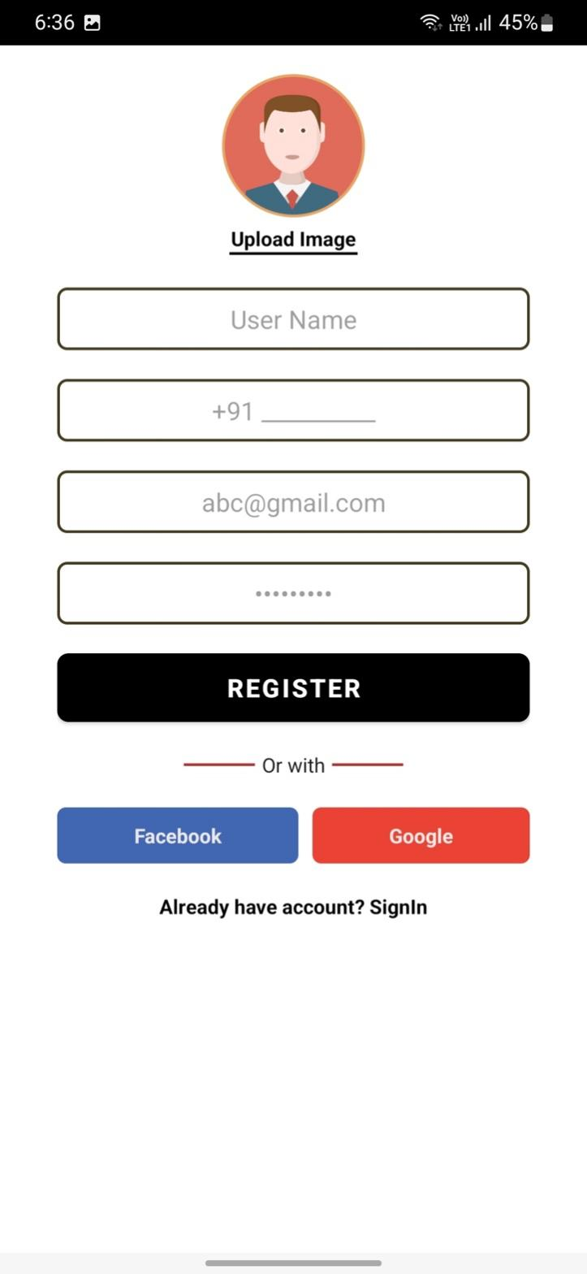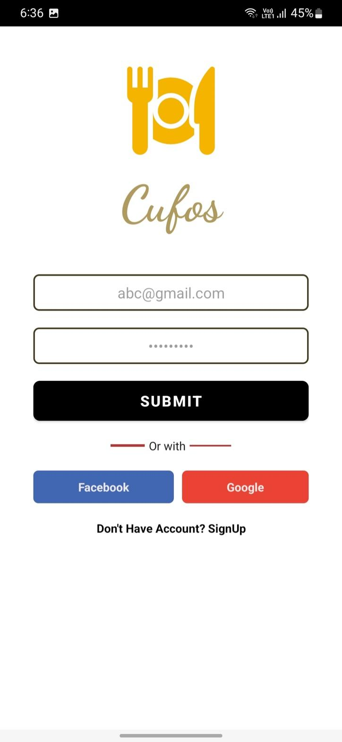

**REFERENCES**

1. Android Studio
2. Firebase
3. https://developer.android.com/studio
4. https://stackoverflow.com/
5. <https://www.tutorialspoint.com/>
6. <https://github.com/>
7. CodeWithHarry